**ANGULAR PROJECT-CINECRITIQ**

**CineCritiq** is a dynamic movie review website designed using Agular.It provide users with a platform to share their thoughts on their favorite movies. The platform offers a **login** feature for returning users and a **registration** option for new users to create an account. Once logged in, users can access their **profile page**, where they can view and manage all the reviews they have added. CineCritiq ensures a seamless user experience, enabling movie enthusiasts to engage with the community and share their opinions effortlessly.

**1.Home Page**

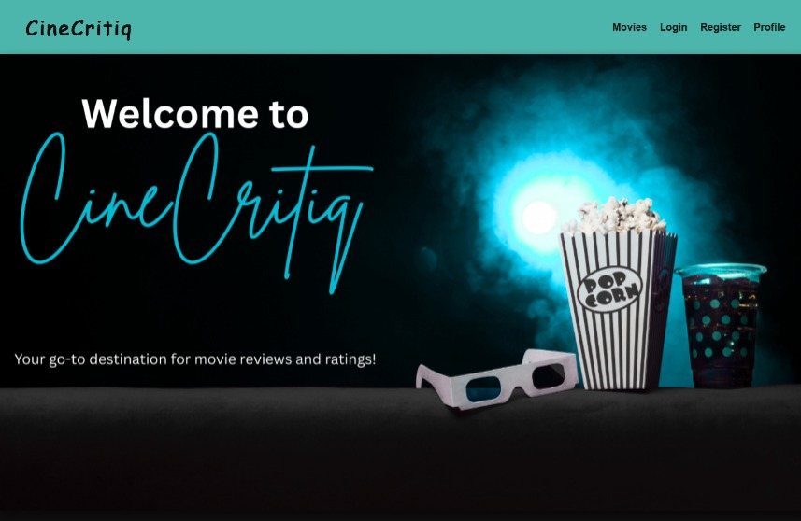

* The **Home Page** of **CineCritiq** serves as the first point of interaction for users, featuring a visually appealing banner image with a welcoming message.
* It sets the tone for an engaging movie review experience.
* The header includes the **CineCritiq title**, which acts as a navigational link—clicking on it will always bring users back to this **Home Page**.
* The design ensures easy access to essential features like **Movies, Login, Register, and Profile**, making navigation smooth and intuitive for users.

**2.Movies Page**

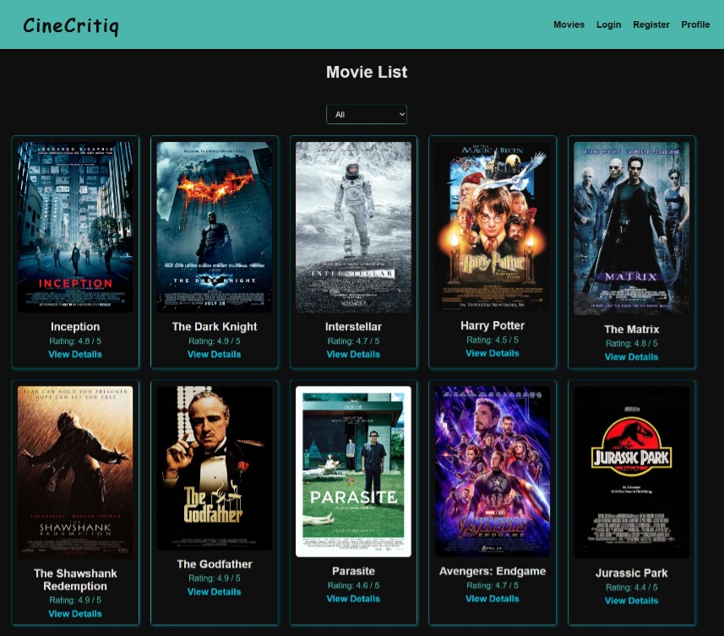

* The **Movies Page** in **CineCritiq** presents a visually structured list of movies displayed as **card components**.
* Each card features the **movie title, rating**, and a **"View Details"** button.
* The ratings are dynamically **fetched from API.**
* Clicking on **"View Details"** navigates users to a **dedicated movie details page**, where they can explore in-depth information about the selected film.

**Genre Filter Pipe**

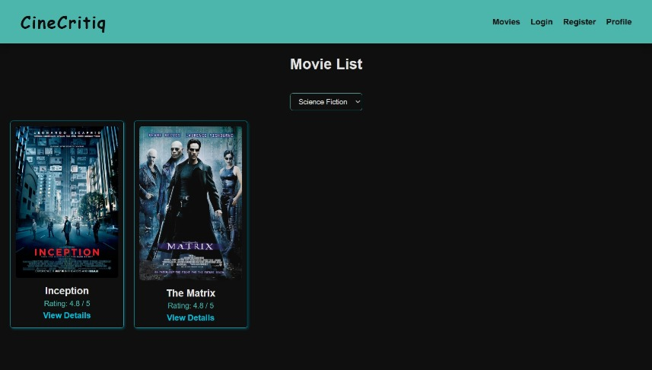

* The **Movies Page** includes a **genre filter** implemented using a **custom pipe**.
* A **dropdown menu** allows users to select a specific genre, dynamically updating the displayed movies to match the chosen category.
* Upon selecting a genre, only movies belonging to that genre are shown, providing a personalized browsing experience.

**3.Movie Details Page**

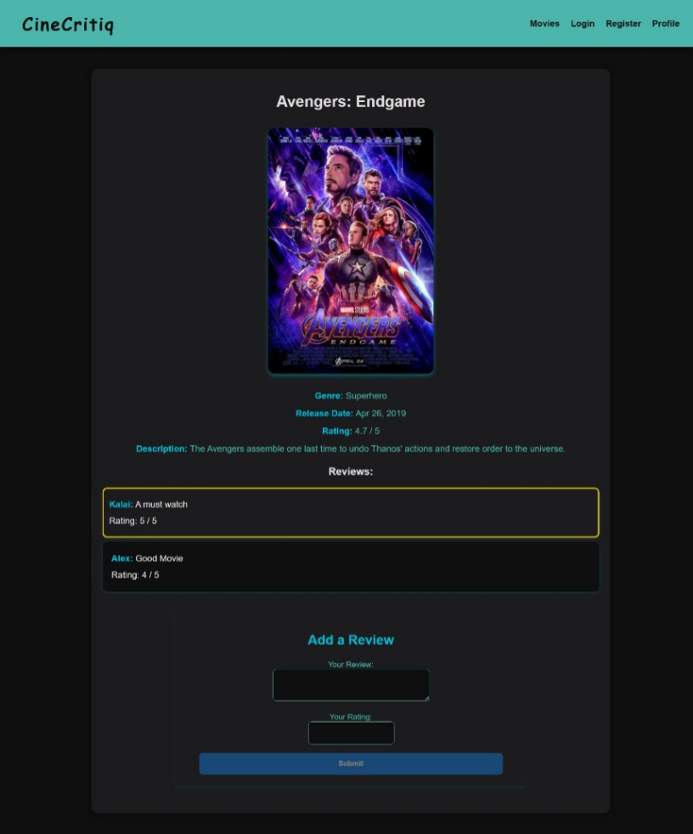

* The movie details page displays comprehensive information about a selected movie, including its **title, image, genre, release date, rating, and description**, all of which are dynamically fetched from API.
* The release date is formatted using Angular's **inbuilt date pipe** to ensure a clean and readable format.
* Below the movie details, the **user reviews** submitted by different viewers are listed, where a custom **ngClass directive** is used to highlight reviews with a perfect **5/5 rating** to visually distinguish top-rated feedback.
* The page also includes an interactive section that allows users to **add their own reviews and ratings.**

**Add Reviews**

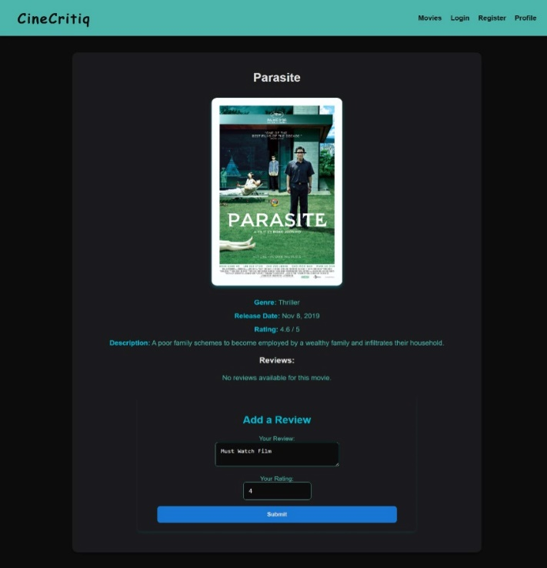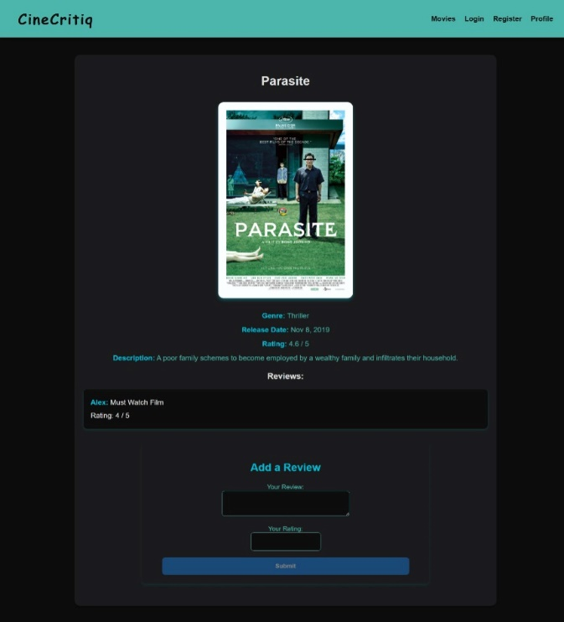

* The **Add a Review** section leverages a **template-driven form** with ngModel for seamless two-way data binding.
* This form allows users to submit their feedback by entering a review and assigning a rating between 1 and 5.
* The review input is handled by a **textarea**, while the rating is captured through an **input field**

**4.Login Page**

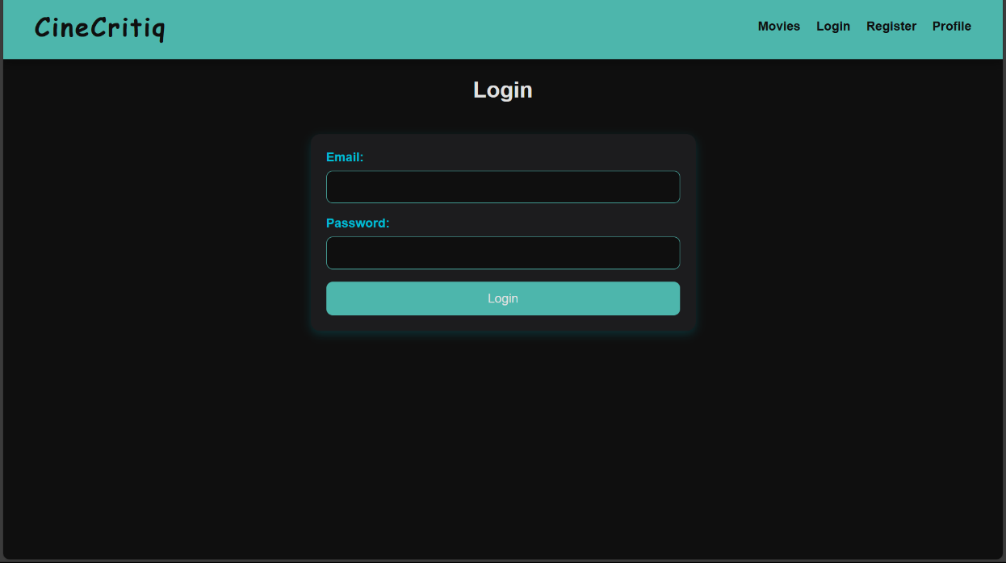

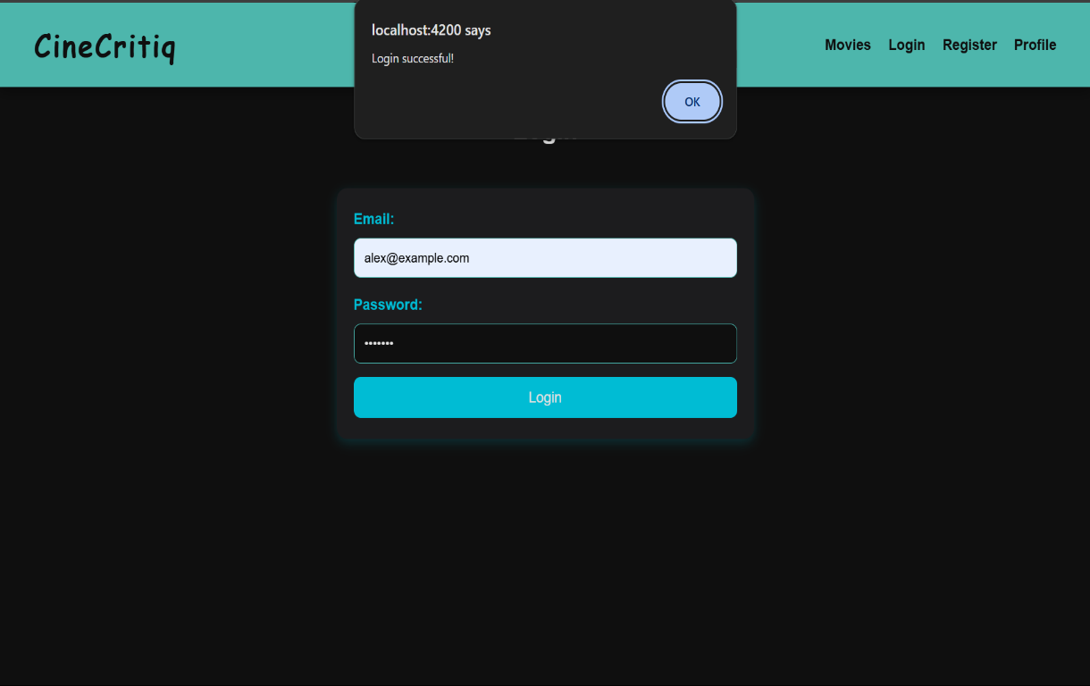

* The **Login Page** is designed with a **template-driven form** using ngModel for two-way data binding, allowing users to input their credentials (email and password).
* Upon clicking the **Login** button, the form validates the inputs and processes the login request.
* If the credentials are correct, an alert message stating **"Login successful!"** is displayed.

**5.Register Page**

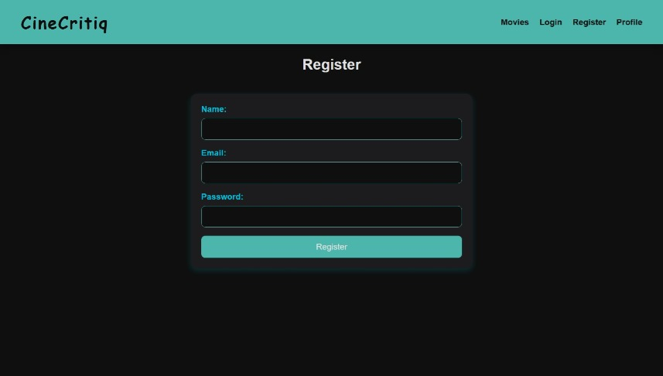

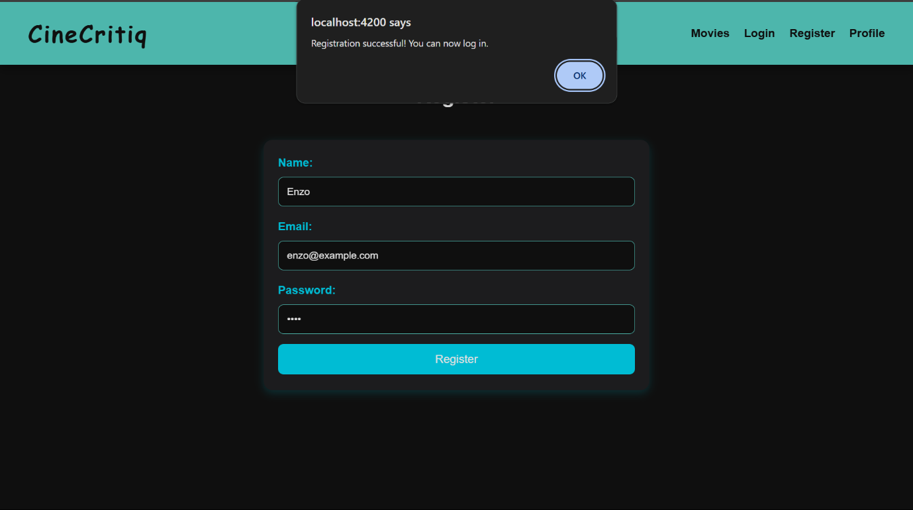

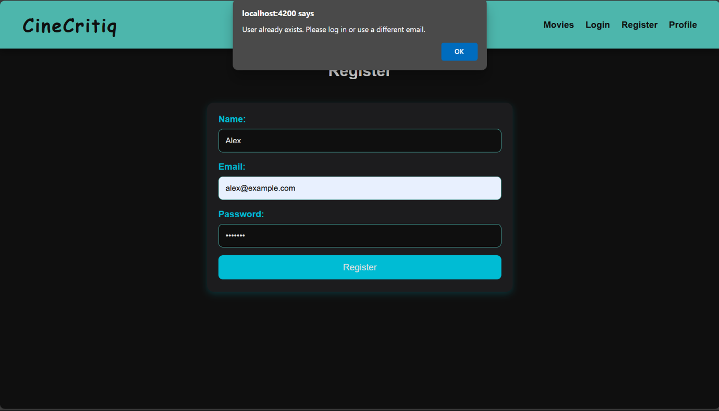

* The **Register Page** also uses a template-driven form with ngModel to collect user details.
* Upon successful registration, an alert **"Registration successful! You can now log in."** is shown, and the user is redirected to the login page.
* If the email already exists, an alert **"User already exists. Please log in or use a different email."** is displayed, preventing duplicate registrations.

**6.Profile Page**

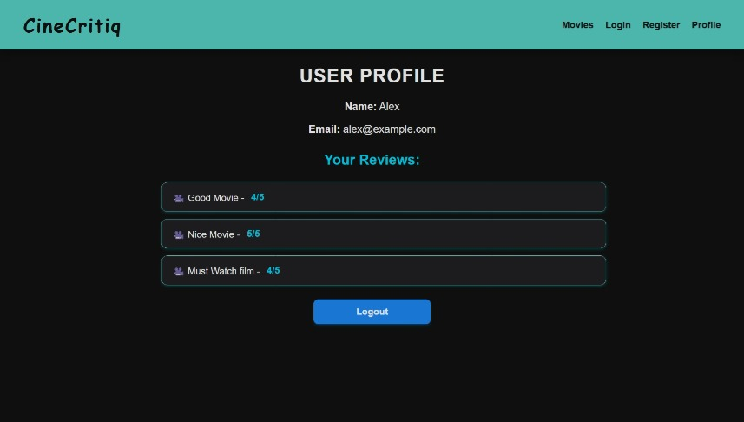

* The **User Profile Page** displays the logged-in user's details, including their **name, email, and reviews**.
* It features a **Logout** button that logs the user out and redirects them to the login page.
* The page uses a **route guard** to ensure that only authenticated users can access it.
* If a user tries to access the profile page without logging in, they are automatically redirected to the **login page**.

**CONCLUSION**

**CineCritiq** project satisfies the conditions as follows:

* **Components:** Separate components for login, register, profile, and reviews.
* **Parent-Child Components:** Review acts as a child component.
* **Directives:** *ngIf, *ngFor (structural), and attribute directives(ngClass) for styling.
* **@Input, @Output:** Passing review data between parent and child.
* **Routing and Routing Parameters:** Navigation with route parameters for dynamic content.
* **Local Storage:** Storing user authentication and review data.
* **Routing Guard:** Restricts profile access to logged-in users.
* **Services and Observables:** API calls and data handling using services (movie service,user service) with observables.
* **API Call:** Fetching movie and review data dynamically.
* **Form Handling:** Login, register, and review forms use template and model-based approaches.
* **Inbuilt Pipes:** Using inbuilt date pipe to display the release date.
* **Custom Pipes:** Custom pipe like genre filter pipe to categorize movies based on genre.